Web Application Development Lab

JavaScript

1. **Find how you can write functions in JavaScript. Describe it.**

Var <nameofthefunction> = function () { Block of code here}

*/* We call this ones arrow functions in ES6 */*

Var <nameofthefunction> = (*parameters*) => * block of code*

1. **Check the example “Future Value Calculator” included in Blackboard from Murach’s Javascript book. Describe which elements and functions are defined.**

**HTML file :**

We have a form where we ask the user for input values such as investment, rate and years.

**JS file:**

We declare at the beginning a function where we want to avoid repeated code so we declare a function where we replace ‘document.getElementById() for $’

We save in variables the values that the user filled in the form and transform them into floats.

We make the calculation to get monthlyRate, months and future value, but first we have to verify that the investment, annualRate and years are valid numbers greaters than 0.

At the end, we replace the value of the input field on futureValue with the result of the calculation and display just two decimals.

1. **Build a web page that prompts for the circle radius and when a button “Compute Data” is pressed, it should display in the same page the circle area and circumference. You can use the constant Math.PI. Use functions.** 
   1. circunference= 2Πr,
   2. area = Πr2 .
2. **Build a web page that prompts for 3 integer numbers and when a “Biggest” button is pressed it should show the biggest number within a paragraph. Change the color of the text. Use an external JavaScript.**
3. **Build a web page that asks for a number using window prompt and write in a table the numbers from 0 to the number given by the user, followed by the square of this number.**
4. **Build a web page that asks for a number within a web page and when a button “Compute” is pressed, the sum of numbers from 0 to the value given by the user should be included in a paragraph. Also show an alert displaying “Sum computed”.**
5. **Build a web page to calculate sales tax. Subtotal and Tax rate (percentage) should be asked to the user. Then, sales tax and total should be displayed in textboxes when a Calculate Button is pressed.**

During the lab, test the applications with valid and invalid data.

**Images of the exercises**

**Calculate-circle**

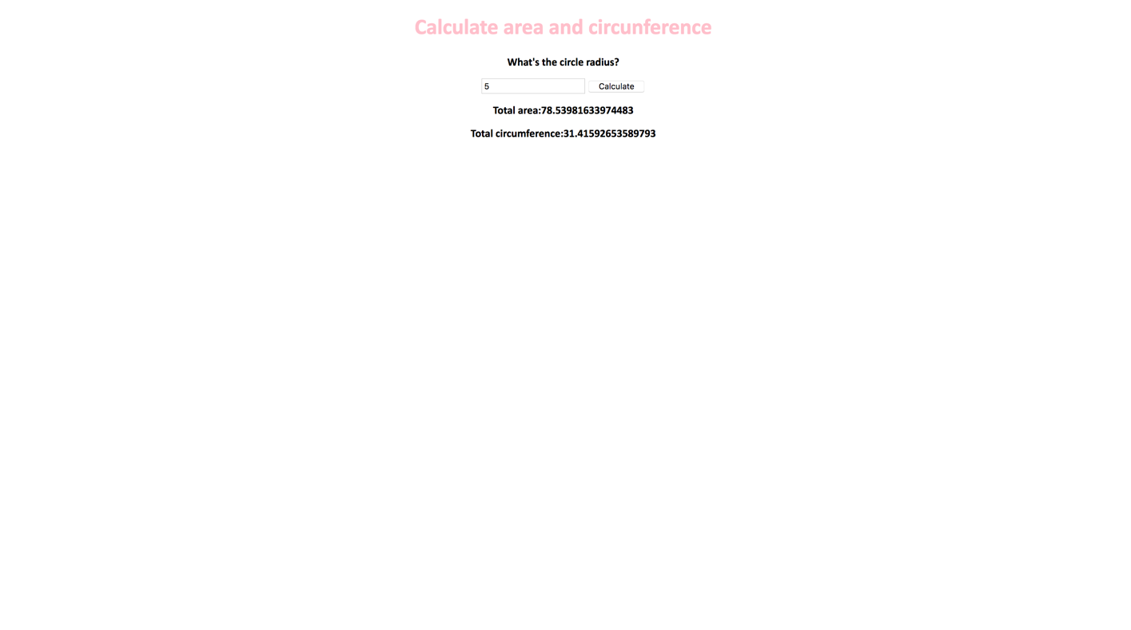

**Biggest Number**

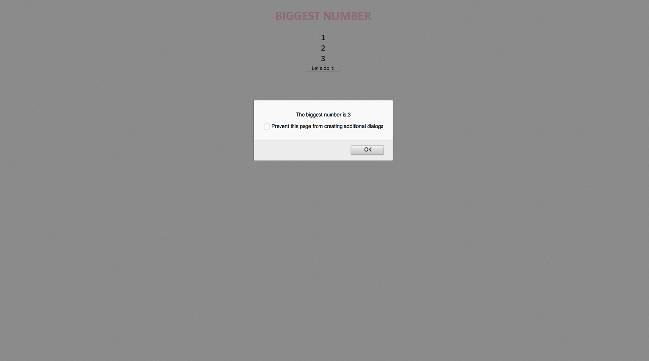

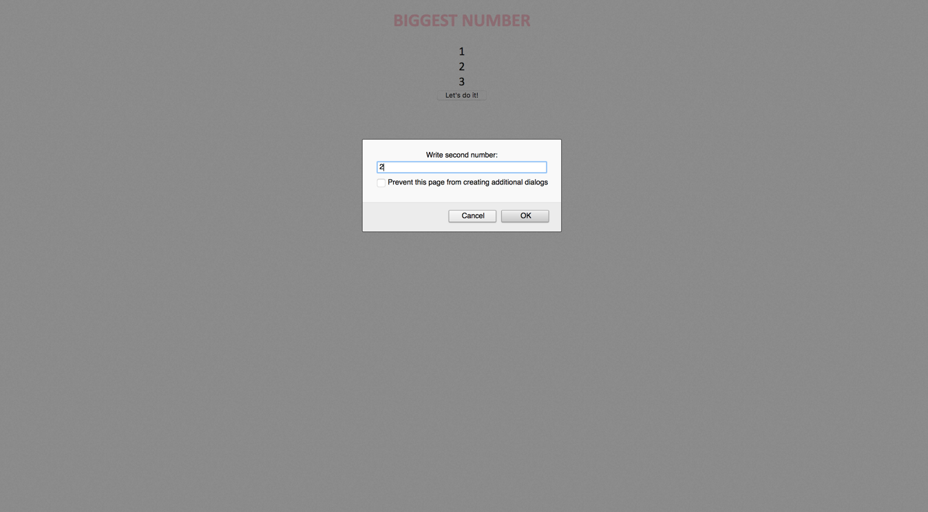

**Sum of Numbers**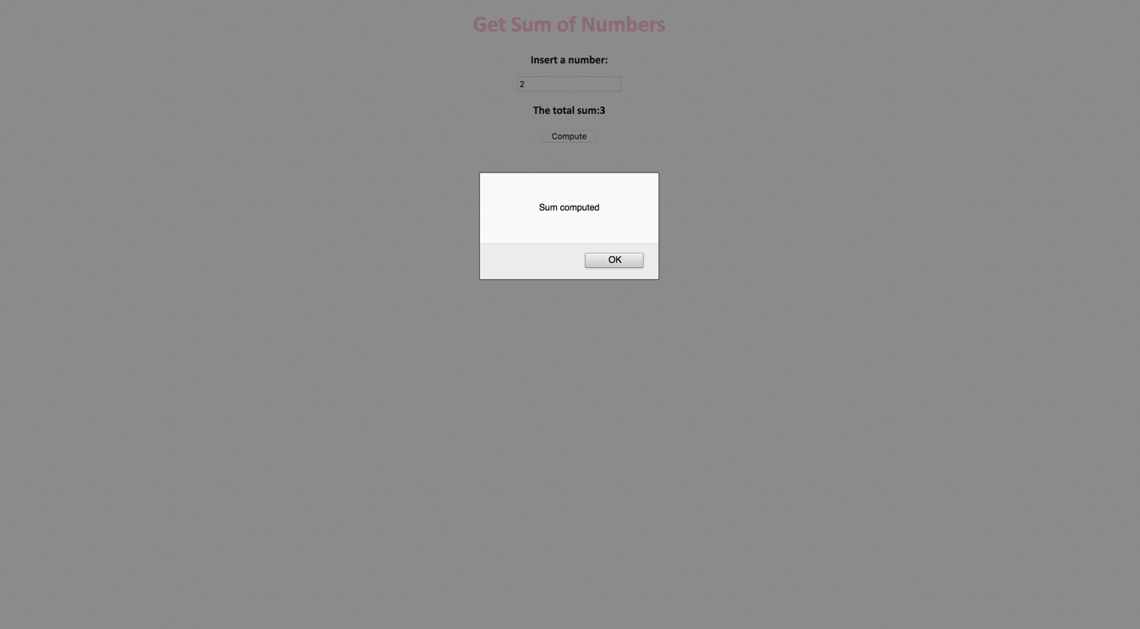

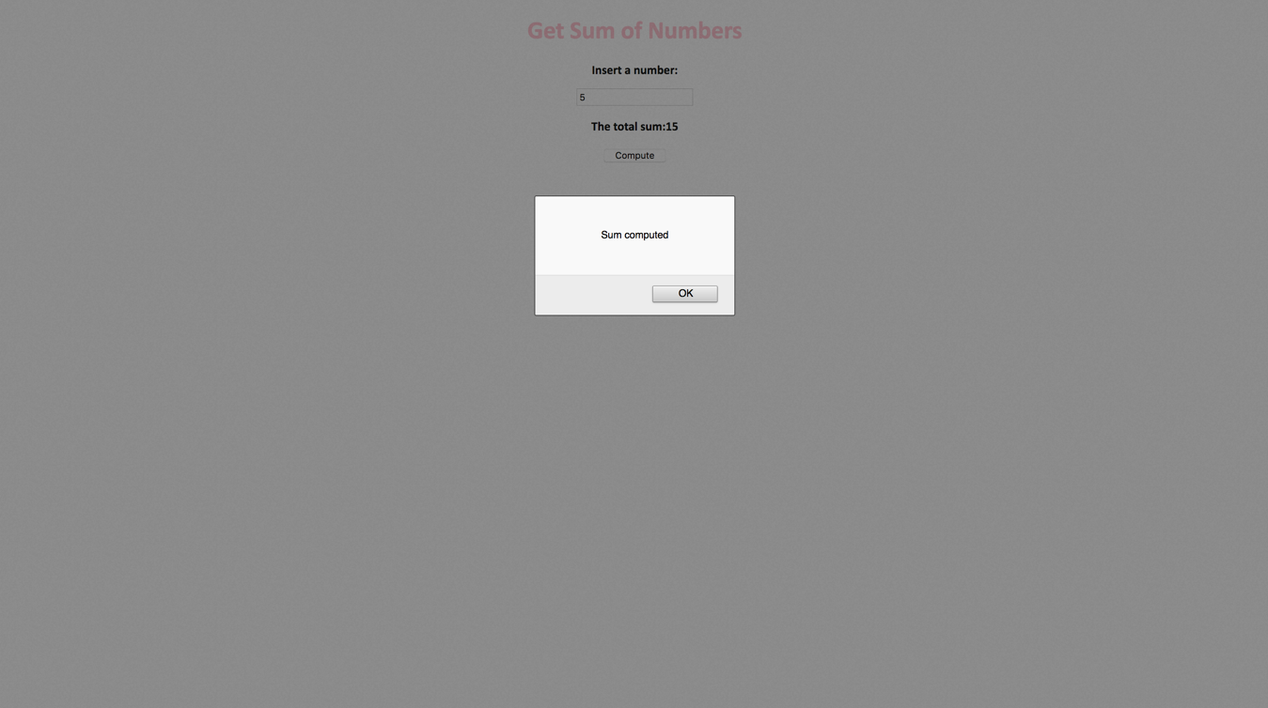

**Taxes**

